The One-Page Income System
How to Earn ₱2K to ₱10K a Day Using a Simple Digital Product, a Facebook Post, and a System That Runs in the Background
By Jon Oraña

A True Story of How One Filipino Built a Daily Income Stream Without Selling to Friends, Without Being a Burnout Entrepreneur, and Without Leaving the House.
For regular Filipinos who want peace, time, and real leverage.
This is not a hustle. This is a system.

Real People. Real Transformation.
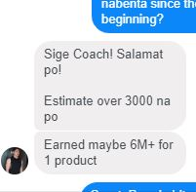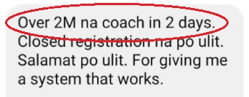
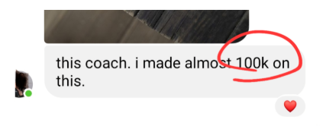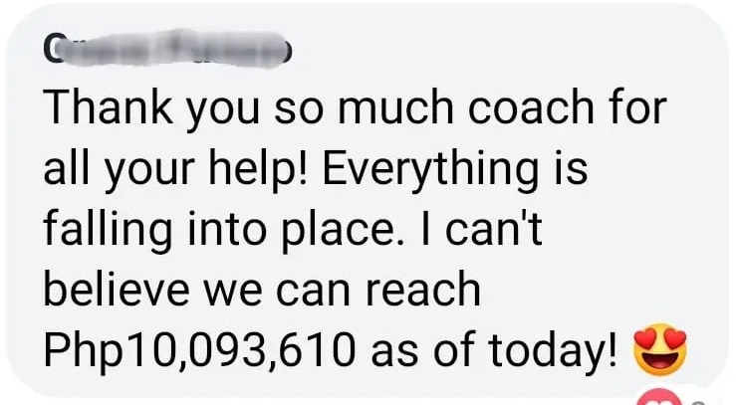
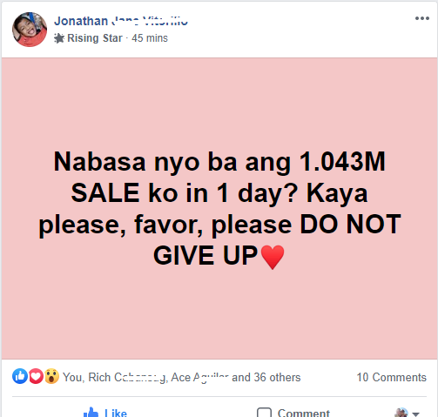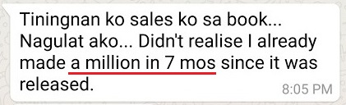

INTRODUCTION
You’re probably wondering if it’s really possible to earn daily online income — especially from home, in your pambahay, and without selling to friends or learning complicated tech.
I get it. That’s what I wondered too.
This guide isn’t some overnight “get rich” promise.
It’s about building what I call a One-Page Income System — a simple, quiet method for earning ₱2,000 to ₱10,000 a day using just:
- a digital product (yes, even if it’s just a Google Doc)
- a single Facebook post
- and a system that runs in the background
No clients. No ads. No burnout.
Just smart income designed around your lifestyle — not the other way around.
“But Jon… ₱10K a day? Really?”
Let me be honest.
When I started this journey, my first sale was around ₱800. I had no following. No fancy tools. Just a second-hand laptop and a small idea I turned into a PDF.
But that one sale changed everything.
₱800 became ₱2,400…
₱2,400 became ₱12,000…
And eventually, yes — I built it into a system that earned me up to ₱30,000 a day.
But that’s not where you start.
You start with one product.
One page.
One post.
You build your first digital income quietly — without begging, dancing, or hustle culture.
If that’s what you want…
Then you’re holding the blueprint.
And here’s the crazy part…

When I started, there was no Facebook. No Google Docs. No Canva. No ChatGPT.

Everything I did, I figured out the hard way.

That’s why I believe you’re in a much better place than I was.

Today, you can write an eBook in Google Docs.

You can post about it on Facebook.

You can collect payments through GCash, Maya, or PayPal.

The tools are free. The steps are clear.

And the system you’re about to learn in this book?

It’s easier, faster, and more powerful than anything I had back then.

So let’s begin.

WHAT THIS IS NOT
Let’s Clear the Bullsh*t

Before we dive into how this One-Page Income System works, let’s be clear.

If you’ve been burned by “online opportunities” before, I get it.

So let’s start with what this is NOT — para you can read the rest with focus and peace of mind.

This is NOT MLM or networking.
No need to recruit your friends or tita from Hongkong.
No downlines. No uplines. No overpriced juices or lotions.
This system works even if ikaw lang mag-isa.

This is NOT crypto, forex, or flipping NFTs.
This isn’t a guessing game.
You don’t need to “monitor the charts” or pray your investment doesn’t crash habang natutulog ka.
This is a real business that creates real value—for real people.

This is NOT about becoming a content creator or YouTuber.
You don’t need to dance on TikTok, post selfies, or be an extrovert.
This system can be done behind the scenes—even without showing your face.

This is NOT selling other people’s products for tiny commissions.
Affiliate marketing is okay. I did that in the beginning back in 2008…
But earning ₱50 from every sale? Tapos ikaw pa gagawa ng video or ads, ikaw pa customer support?
You’re doing all the work, getting paid the least.
This system flips that: YOU own the product. You keep the profits.

This is NOT a get-rich-quick scam.
Real talk lang tayo, ha?
I don’t want to insult your intelligence and make you feel this is very easy.
If you’re looking for a “magic income app” or “easy ₱10K today” type of hustle…
Hindi ito yun.
But if you want a system that works—and are willing to learn, apply, and commit—then this is exactly what you’ve been looking for.
This is not a trick. This is not hype.
This is a simple online business that leverages information + automation + digital tools.
And no, you don’t need to be techy.
You just need to be serious.
This is a lifestyle-first digital system—designed to give you time, peace, and profit using what you already know.

Chapter One
How I Made My First ₱800 Sale in Pambahay — and Turned It Into Daily Income That Scales
Let’s be honest.
If you saw a Facebook ad that promised you could make ₱2K–₱10K a day from a Google Doc and one post, your first thought would probably be:
“Scam ‘to.”
“Wala namang ganyan kadali.”
“Clickbait na naman ‘to.”
I don’t blame you.
You’ve probably seen it all — flashy gurus showing off GCash notifications, sports cars, and testimonials na sobrang polished, parang scripted.
That’s not what this is.
This isn’t about posing.
This is about building.
And I’m not asking you to believe me blindly.
All I ask is this: keep reading.
Because what I’ll show you next is exactly how I made:
- ₱800 from my very first sale
- ₱1,800 a few days later
- ₱6,000 the week after
…and eventually, ₱30,000 a day — not from hype, but from a repeatable system
(Note: These are estimated conversions from USD to PHP at the time. I was selling in dollars — starting at $17 — but for simplicity and relatability, I’ll use pesos throughout this guide.)
But let’s rewind.

Chapter Two
I Can’t Believe I’m The One Writing This Book
I wasn’t born for business. I never thought of myself as “entrepreneurial.”
And I definitely didn’t imagine I’d one day write a book about earning ₱30,000 a day—online.
But here we are. Because sometimes, life forces you to figure it out.

I Got Fired.
Yup. Nawalan ako ng trabaho.
Not because I was lazy. Not because I didn’t do my job.
It was politics.
Restructuring daw. The usual corporate excuse.
After years of showing up, meeting deadlines, giving my best...
I got a 10-minute office meeting and a polite “thank you for your service.”
No warning. No backup plan. Just silence and a growing sense of panic.
I remember staring at my computer, trying to act okay in front of my family.
But deep inside, I was scared.
Embarrassed.
And honestly—galit.
“Ganito na lang ba ‘to? One meeting and it’s over?”

Then Something Snapped.
One night, habang nagkakape sa sala, wearing my usual sando at shorts, I asked myself:
“Pano kung ito na yung sign?”
“Pano kung hindi ko na kailangang maghanap ng trabaho ulit?”
“Pano kung may paraan to make income without begging anyone to hire me?”
That night, I wrote down everything I knew.
Skills. Experience. Things I’ve figured out.
Not as an “expert,” but as someone who figured out real stuff that could help someone else.
The next day, I turned one of those ideas into a tiny e-book.

The First Sale Changed Everything

After a few weeks of panic and overthinking, I landed a new job.

It paid okay.

But something changed in me.

I told myself:

“Next time I lose a job, I won’t be this helpless again.”

“I need a Plan B — something I own. Something no one can take away.”

So I did something different.

At night, after work — while everyone was watching TV or browsing online— I opened a blank page and wrote down everything I knew.

Not to impress anyone. Not to launch a business.

Just to see if I had something useful to share.

I asked myself:

“What’s something I’ve struggled with… but eventually figured out?”

“What’s one thing I wish someone had helped me with when I was starting out?”

And I remembered this one thing:

I used to struggle to memorize Bible verses.

As a Christian, I was part of a small Bible study group.

And from time to time, we were asked to share short exhortations or encouragements.

Having Scripture ready — from memory — would have helped me speak with more confidence.

So I created a simple 50-page guide.

I shared the exact steps I used to memorize verses better — even with a busy schedule.

No fluff. No theology degree.

Just something real and useful for someone like me, a few steps back.It wasn’t a business idea.

It wasn’t even sexy.

But it was real.

I turned it into a short PDF.

Then I posted about it on a Christian forum and website.

No ads. No followers. No team.

Just a helpful product… and a quiet Plan B.

And then the next morning?

I got a notification. Someone bought my guide.

It wasn’t a friend. Hindi sya churchmate.

It was a complete stranger — someone I had never met, who saw my post and decided:

“This could help me.”

₱800.

That was the price of the guide. Small to some people.

But to me, that moment was massive.

(Note: I sold it in USD — $17 at the time. From here on, I’ll use pesos for simplicity.)

I stared at the email baka kako glitch.

Then I refreshed the page.

Still there.

That first sale made something click in my brain:

“So this is possible.”
“I can actually earn from what I know or interest.”
“I don’t need to be a guru — I just need to be helpful.”

That sale didn’t just give me ₱800.

It gave me PROOF it works.

Why I’m Telling You This
I’m not telling you this to impress you.
I’m telling you this because if you’ve ever felt stuck…
…if you’ve ever wondered if you could earn without burning out…
…if you’ve ever thought, “Maybe I have something to share, but I’m not sure where to start…”

Then maybe — just maybe — you’re one post away.
I was just a regular guy trying to find a way out.
I didn’t have a business plan.
I didn’t even know it was called a “digital product.”
But I took what I knew…
Packaged it simply…
Shared it honestly…
And someone paid for it.
No hype. No ads. No “launch strategy.”
That’s why I’m sharing this with you.
Because today, with tools like Google Docs, Facebook, and ChatGPT — what I did years ago?
You can now do faster. Easier. With more support.
Again, you don’t need to be an expert.
You just need to start with what you already know — and let the system do the heavy lifting.

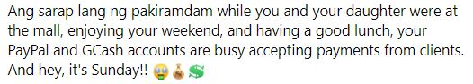

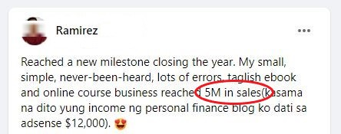

Chapter Three
The One-Page Income System — Your First Step to Smart, Daily Digital Income
Let’s take a step back.
Before we dive into “how to start,” you need to understand how this system works from top to bottom.
This isn’t magic.
It’s not “manifestation.”
And it’s definitely not a lucky viral post.
It’s a simple 7-part system that works together like gears in a machine.
When people hear ₱2,000 - ₱10,000 a day, they think:
- Vlogging?
- Dropshipping?
- Crypto?
- Forex trading?
- Influencer life?
Nope. I don’t do any of that.
This system doesn’t rely on fame, ads, constant posting, or lucky break.
It’s designed for regular people who want a system that runs quietly in the background while they live their lives in peace.
Kahit nasa abroad ka ngayon — kahit nurse ka sa Germany, seaman sa barko, o nag-aalaga ng bata sa Middle East — this system can start wherever you are. At habang pinalalago mo siya, unti-unting lumalapit ‘yung goal mo: makauwi for good, na may steady kita kahit wala ka sa abroad.
Let me give you the big picture first:

The 7 Parts of the One-Page Income System

- Find a Pain That Pays
– Don’t sell random info. Solve real problems. Kung hindi masakit, hindi sila magbabayad.
- Create a Digital Product
– Package your solution into something people can buy. Even if it’s just a Google Doc. No need for courses, websites, or big production. Kahit short PDF, checklist, or template — basta useful.
- Build a 1-Page Sales System
– No need for a full website. Just one clear page that explains the problem, the solution, and how to buy. Google Doc lang? Pwede.
- Use Social Media as Your Sales Machine
– You don’t need to be an influencer. You don’t even need 1,000 friends.
You just need to post value — and attract the right people. One good post can bring in ₱2,000… ₱5,000… even ₱10K a day.
- Follow Up with Automation
– Use tools to follow up and close sales 24/7.
- Introduce Higher-Tier Offers (Optional)
– Once someone buys your product…some will want more. That’s where you can offer coaching, templates, or done-with-you help — only if you choose to.

No pressure. No extra work — unless you want higher profits.
- Systematize and Step Back
– Once it works? Repeat. Automate. Delegate. That’s when you go from ₱2K/day to ₱10K and beyond — without getting busier. Yan ang tunay na Chillyonaryo.
This system works because it’s simple.
Each part supports the next. And when it clicks, it clicks big.
I’ll break down each one in the next seven chapters.
But here’s a warning: If you skip even one step, the whole thing gets shaky. Mahina ang pundasyon mo.
That’s what most people do—they skip steps, chase shortcuts, and wonder why nothing sticks.
You’re not going to do that.
You’re here to build something real. A legit business that will give you the freedom that your friends can only dream of.
And now, we start with Step 1.

Chapter Four
Find a Pain That Pays
Let me give it to you straight:
People don’t pay for information.
They pay to stop their pain.
Period.
Most people who try to make money online get this part completely wrong.
They start with what they want to sell instead of what people want to buy.
And that one mistake?

That’s the reason many stay stuck at zero.

Ang daming nagbebenta ng “passion project.”

Pero wala namang willing magbayad.

That’s the harsh truth.

Do You Want to Be Right, or Do You Want to Get Paid?
Let me guess.
Marami kang ideas.
You’ve probably said something like…
“I want to sell something I’m passionate about!”
“Gusto ko yung fun gawin!”
“Ayoko naman ng masyadong salesy.”
Okay. But let me ask you this:
If you created something you love…
...but no one’s actually willing to pay for it…
Would you still call that a business?
No.
That’s a hobby.
And hobbies don’t pay the bills.

The Harsh Truth Nobody Tells You
Here’s what I learned after wasting years chasing trendy ideas:
Money doesn’t come from creativity.
It comes from solving painful, expensive problems.
People won’t pay you just because you’re passionate.
They’ll pay you to help them:
- Lose weight
- Make money
- Find love
- Save time
- Reduce stress
- Avoid embarrassment
- Feel safer
- Look smarter
The more painful the problem? The easier the sale.

The Formula I Use
If you want to print money online, here’s the simplest formula in the world:
“Who is in pain, and what are they trying to fix?”
If you can answer that honestly—you're already halfway there.
Let me give you a few real examples I’ve seen work:
- For OFWs:
“How to earn ₱60K/month online while working abroad—so you don’t have to go home broke.”
- For new freelancers:
“How to get your first client in 7 days without using Upwork or Fiverr.”
- For new moms:
“Lose baby weight at home—without giving up rice.”
- For single men:
“How to turn chat into dates.”
- For soon to be bride:
“Wedding planning for clueless bride-to-be.”
Now here’s what doesn’t work:
- “How to find your true passion”
- “Learn Canva for fun”
- “Journaling 101”
- “Discover your inner creativity”
- “My life story.”
Why? Because people don’t wake up at 2:30 am stressing about how to become creative.
But they do wake up worrying about money, their weight, their job, single pa din sila, or utang nila na hindi matapos-tapos.
That’s where your offer fits in.

Still Don’t Know What Problem to Solve?
Look inward.
Ask yourself:
- What have I figured out in my life that others are still struggling with?
- What do people always ask for my advice about?
- What did I used to suck at, but now I’ve improved?
Remember, you don’t need to be an expert. You just need to be one step ahead.
If you lost 20 pounds, you can help people lose 10.
If you landed your first client, you can teach others to do the same.
If you learned how to budget even on a small salary—you’ve got something worth sharing.

Bottom Line:
If your product doesn’t solve a real pain, no one will care.
If it does, they’ll pay you today.
And tomorrow.
And the next day.
So before you dream up your brand name, logo, or course title—do the one thing most people skip:
Find a pain that pays.
It’s not flashy. But it’s profitable.
And if you get this part right, the rest will fall into place.

Try This With ChatGPT:
If you’re stuck or not sure what pain to focus on, here’s a simple prompt you can copy-paste into ChatGPT:
Prompt:
“Give me a list of painful problems faced by [insert your target audience], especially ones they’d be willing to pay to solve. Focus on topics related to money, health, career, time, relationships, or confidence.”
Example “target audience”:
- OFWs
- New moms
- Dog owner
- Freelancers
- Senior citizens
- School Teachers
Sidenote: Don’t target jobless, fresh graduates, or students. Unfortunately, wala silang disposable income.
ChatGPT might give you results like:
- “OFWs afraid of going home broke after years abroad”
- “Teachers struggling to budget with low salaries”
- “Freelancers with no consistent clients”
- “Moms who can’t lose weight without expensive diets”

Next Step:
Pick one that:
- You personally relate to, or
- You can help with (even just one step ahead)
That’s your business starting point.
Don’t overthink. Just pick one pain.
We’ll turn that into a digital product in the next chapter.

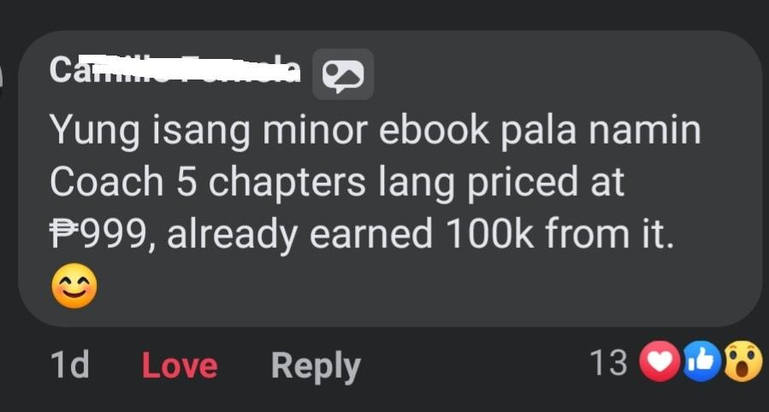

Chapter Five
Create a Digital Product That Sells Itself
Now that you’ve found a real problem to solve, let’s talk about turning that into an actual product.
No, you don’t need to code anything.
No fancy app. No big production team. No filming in a studio.
You just need one thing:
A simple, digital solution that someone is willing to pay for.

What Is a Digital Product?
Here’s the simple definition:
It’s something you create once and sell again and again—without delivering it manually each time.
It’s not tied to your time, unlike freelancing. It’s not physical.
And it doesn’t need inventory or delivery riders.
Here are examples that work:
- E-books
- Checklists
- Video lessons
- Templates
- Swipe files
- Mini-courses
- Worksheets
- Recorded Zoom workshops
Yes—even a simple Google Doc with the right info can sell.

But Who Am I To Teach Anything?
This is the voice of insecurity.
I’ve heard it too. I said it myself.
“Who would buy from me?”
“I’m not an expert.”
“Wala naman akong certification.”
Let me tell you what people care about:
- Can you help me fix this problem?
- Can you explain it in a way I’ll understand?
- Will this save me time, stress, or money?
If the answer is yes… they’ll buy.
Not because you're a guru.
But because you’re one step ahead of them.
That’s all it takes.
Now, maybe nasa isip mo…
“Bakit naman may bibili ng PDF ko? Di ba libre na lahat sa internet?"
Valid question.
Libre nga sa internet ang info, pero kalat-kalat. Ang binabayaran ng tao ay 'organized clarity'—isang guide na step-by-step, tested na, at clear and direction.

The Simpler, The Better
People don’t want complicated.
They don’t want 47 modules, 12 PDFs, or a 200-page textbook.
They want clarity. They want speed. They want the shortcut.
So instead of asking:
“What can I include?”
Ask:
“What can I remove?”
I’m telling you, after doing this for 17 years, this simple question of “What can I remove?” helps my clients a lot.
Para kasing common sense na bigyan mo sila ng sangdamakmak na content e. Right? Nag-bayad sila e.
But your goal is to deliver a transformation in the simplest, fastest way possible.

Real Examples That Worked
Let me show you how simple this can get:
- An OFW created a 30-page guide on “How to Earn Online Without Getting Scammed” – sold 60+ copies at ₱499.
- A mom from Pangasinan sold a 30-day meal plan with low-cost healthy meals – no video, just Google Sheets.
- A public school teacher from Bohol created a ₱399 digital reading module for Grades 1–3. In just one week, nakabenta siya ng 40 copies—simple lang ang format, pero structured at malinaw. Kasi nga, hindi mo kailangang maging “influencer”—ang kailangan mo lang ay alam mong may natutulungan ‘yung gawa mo.
- A former BPO employee sa Makati made ₱150K in 30 days teaching “How to Become a Virtual Assistant.”
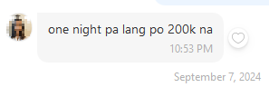
None of them were influencers.
None had a team.
All used simple digital products.
You can too.

How to Structure Your Product (Even If You Don’t Know Where to Start)
Here’s a basic outline that works for almost every topic:
- The Problem – Why this matters
- The Big Idea – The mindset or secret they need to understand
- The Steps – Step-by-step breakdown (usually 3 to 5 steps)
- The Tools – Templates, scripts, examples, worksheets
- The Shortcut – Tips, mistakes to avoid, bonus hacks
- The Next Step – What to do after (or upsell to your next offer)
That’s it!
Write this in Google Docs.
Record it on Zoom or Loom.
Upload it to Google Drive.
Boom!
You’ve got a product.
This Isn’t School. It’s Business.
‘Wag kang mag over-explain. Don’t aim to impress.
Aim to solve the problem as clearly and quickly as possible.
If your product saves them 5 hours of stress or gives them a ₱50,000 opportunity—charging ₱500, ₱1,500, or even ₱5,000 becomes easy.
Don’t forget: You’re not selling pages or information. You’re selling results.

Chapter Six
Build a 1-Page Sales System That Sells
While You Sleep
Here’s what most people don’t realize:
It’s not your product that makes money. It’s your ability to explain it in a way that makes people want it—right now.
And guess what?
You don’t need a full website.
You don’t need a funnel software subscription.
You don’t need 12 pages of design.
You just need one single page that does all the heavy lifting for you.
Hindi mo kailangan maging marketer. Hindi mo kailangan ng flashy design o sales tricks. In fact, kung sanay ka sa reports, memos, or government proposals—mas may advantage ka pa.
This Chillyonaryo style system is built for clarity, not hype. Gamit lang ang konting diskarte mo, kayang-kaya mo ‘to.

What Is a 1-Page Sales System?
It’s a simple page—just one—that tells your prospect:
- What the problem is
- What your solution does
- What they’ll get
- And how to buy it
Yung lang!
Think of it like your online tindahan, but for “information.”
People scroll, read, nod, click “Buy Now,” pay—done.
While you’re asleep. While you’re out for coffee. While you’re doing literally anything else.

The Anatomy of a Killer Sales Page
Here’s what it needs. No more. No less.
- Headline That Hits a Nerve
“How to [solve a painful problem] without [frustrating thing they hate].”
Examples:
- How to Get Freelance Clients Without Using Upwork
- How to Lose Weight Without Giving Up Rice
- How to Make ₱50K Online Without Talking to Anyone

A Short Story or Pain Point
Talk about the problem.
Make them feel seen.
Show them you’ve been there too.
- Your Big Promise
What exactly are they going to get?
What’s the result? Be specific.

What’s Inside
Break down what they’ll receive—eBook, video, checklist, etc.

The Price
Say it proudly. No need to “justify” it.
Simple product = simple price.

The CTA (Call to Action)
Tell them what to do next.
Example:
Click the button below, pay via GCash or card, and you’ll get instant access.
That’s it, pancit!

“But I Don’t Know How to Write Sales Copy…”
Good news.
You don’t have to.
Because today? You can get 80% of the way there using ChatGPT.

Try This With ChatGPT:
Prompt:
“Write a simple but persuasive sales page for a digital product that helps [target audience] solve [painful problem]. Keep it conversational, emotional, and clear. Use bullet points and call-to-action language.”
Replace the brackets with your offer, and you’ll get a decent first draft in seconds.
Then adjust it to sound more like you—and boom. You’ve got your sales page.

Where Should I Host This?
Here are beginner-friendly options that work in the Philippines:
Most straight-forward: Google Docs (yes, it works)
I get it. It sounds too simple to be true.
Pero eto ang totoo:
One of my best-performing sales pages?
Hindi naka-WordPress. Hindi rin fancy website na may animation.
It was a plain Google Doc—with words that hit the pain and promised a clear result.
Frankly, people don’t buy because of design or kung san naka-host yan.
They buy because they believe your offer can help them.
And if a Google Doc can do that? That’s not “cheap”—that’s leverage.

Sa totoo lang, that 1-page Google Doc made me more money than my college degree ever did.
If you treat it like a serious tool, it becomes a serious asset. Copy?
Isang page. Tuloy-tuloy ang kita. Kahit natutulog ka pa.
Few more options:
- Notion (clean and fast)
- Carrd.co (easy landing pages)
- Payhip or Gumroad (already have checkout buttons)
My point is, don’t let tech stop you.
Your sales page doesn’t need to win a design award. It just needs to convince someone to buy. It’s a virtual salesman na working for you 24/7.
The Magic of a 1-Page System
Here’s what happens when you set this up:
- You stop explaining your offer in DMs
- You stop sending screenshots of GCash every time
- You stop answering the same questions again and again
- You finally have a business, not just a side hustle
This page becomes your 24/7 salesperson.
It doesn’t sleep.
Walang reklamo.
It just converts.

One Page. One Product. One System.
That’s all you need to start making money online.
Everything else is just noise.
So before you worry about logos, color palettes, or “launch strategy”…
Build your sales page. Make your first sale. Then scale from there.

Chapter Seven
Use Social Media As Your Sales Machine (Without Going Viral)
Let me say this upfront:
You don’t need to become a content creator.
You don’t need 10,000 followers.
And you definitely don’t need to dance on TikTok.
All you need is a strategy—not virality.
Positioning—not popularity.
Because when done right?
A single Facebook post can pull in ₱5,000, ₱15,000, even ₱100,000 in sales.
And I’ve done it in tsinelas, without boosting a thing.

Social Media Is Not Your Business
It’s Your Billboard.
Stop treating social media like it’s the business.
It’s not.
It’s the marketing arm.
It’s the hook.
It’s where people discover you, relate to you, trust you—then click to buy.
That’s it.
Walang pressure to become an “influencer.”
You’re not here to entertain or magpatawa lang. You’re here to attract the right people who are already in pain—and guide them to your offer.

What Should You Post?
Here’s the formula:

Post Value That Solves Micro-Problems
Give them a taste of what your product solves.
Teach something quick. Make them say:
“Wow, if the free stuff is this good, the paid stuff must be better.”

Tell Stories That Build Trust
Tell them how you struggled.
What you learned.
Show them you’re human—and just like them, but one step ahead.

Drop Soft Call-To-Action (CTAs)
Every few posts, say something like:
“If you want the full version, message me the word ‘ready’.”
“Want the step-by-step guide? It’s inside my eBook. Link in the comments.”
It doesn’t need to be aggressive.
Just real, honest, and helpful.

Where Should You Post?
Start where your audience already hangs out:
- Your Facebook profile – Clean it up. Make it clear what you help with. Post consistently.
- Facebook groups – Not to spam, but to contribute. Be the most helpful voice in the comments. Again, di ka magbebenta dito, but help.
- Your own FB group or page (optional) – Once people follow you, give them a place to stay.
Forget trying to be everywhere.
You can build a six-figure side hustle from just your personal profile alone.
I’ve done it. Others have done it. You can too.

"But What If I'm Shy or Not Good On Camera?"
Perfect.
Because most of the money I’ve made came from:
- Text posts
- Screenshots
- ChatGPT-written captions
- Google Docs
I have videos, but believe it or not, it’s reaching fewer people than a simple text post.
But your content is about solutions. Presented simply. To people already looking for them.
That’s the move.
What Social Selling Really Looks Like
Here’s what you’re building:
- A few solid posts each week
- A link to your sales page
- A few automated follow-ups in the DMs or email
- A bank notification
Rinse. Repeat. Improve. Scale.

Bottom Line:
You don’t need to become the next viral star. You just need to show up consistently with value, clarity, and an offer that actually helps.
Let social media be your magnet.
NOT your prison.
Use it to pull people in. Then let your product and sales system do the rest.

1 Post Today = 1% Closer to Freedom
Let’s be real.
Sometimes your first post will get comments, messages, maybe even a sale.
But most of the time?
It won’t.
And that’s not failure — that’s normal.
This isn’t a viral trick. This is a quiet system.
You’re not just selling a product. You’re earning attention.
You’re building belief — sa ibang tao, at sa sarili mo.
Get this: People don’t buy when it’s convenient for you.
They buy when they finally trust you.
Sometimes that takes 1 post lang.
But most of the time?
It takes 5. Or 10. Or 15.
Each post is like a quiet knock.
“Hey, I’m here. I built something that might help you.”
And every time you show up — with value, with honesty, with zero pressure —
You stand out. Because in a world full of hype, consistency feels like integrity.
The product you created today? Hindi siya mabenta kung walang makakita.
The post you published? Pwedeng hindi nila nabasa. Or hindi pa sila ready.
But the next one? Or the one after that? That might be the one that gets someone to say:
“Sige nga, try ko na nga.”

So post again tomorrow.
Tell another story. Answer their questions. Talk about their struggles. Share a small win.
Repeat your offer.
That’s how you build digital income.
Not by being viral. But by being visible.
Smart income doesn’t come from one clever post.
It comes from quiet consistency.

Chapter Eight
Follow Up With Automation (So You Close Sales in Your Sleep)
Let me tell you the cold truth:
Most people won’t buy the first time they see your offer.
Not because they’re not interested. Not because they’re broke.
But because they’re busy.
Kids. Work. Netflix. Life.
They’ll click. They’ll scroll. They’ll think “I’ll come back to this.”
And they never do.
Unless…
You follow up.

But You Don’t Have Time To Chase People.
Exactly. That’s why we automate it.
Because the only thing worse than losing a sale…
...is losing it just because you didn’t follow up.

The “Invisible Salesperson” Strategy
Here’s the goal:
Set up a system that reminds, nurtures, and closes people—without you lifting a finger.
It’s not complicated. It’s just overlooked.
Here’s what it can look like:

Option 1: Email Follow-Ups
Someone visits your page, signs up, or buys?
Send them:
- Day 1: “Here’s what to expect…”
- Day 2: Story about how you figured this out
- Day 3: Common mistake they’re making
- Day 4: A client win or lesson
- Day 5: Final reminder
Use tools like MailerLite, Systeme.io, or ConvertKit to automate this for free or cheap.

Option 2: Chat & DM Automations
You can now trigger follow-ups using:
- FB Comment tools (like ManyChat or AI chatbot flows)
- Pre-saved messages you can send in 2 clicks
- VA support or part-time help to reply using a script
Your goal?
Make it easy for interested people to get back in the loop without you chasing them.
Option 3: Soft Re-Posts
Even without tools, you can “follow up” by re-posting:
- A shorter version of your original post
- A new angle on the same problem
- A client result or testimonial
- A fresh story that re-frames the same offer
Fact is, people don’t see all your posts. They forget. They scroll past.
But when you follow up? You catch them at the right moment.
That’s where the sale happens.

But Isn’t That “Too Much”?
Nope.
Think about it this way:
If someone still hasn’t solved their problem…
And you have the solution…
Aren’t you doing them a favor by reminding them it exists?
That’s not being pushy. That’s being smart.
And profitable.

Automation + System = Freedom
This is how you:
- Stop repeating yourself
- Stop losing leads
- And stop relying on “hope” as a strategy
You wake up. Open your phone. And boom—GCash or Paypal payment while sleeping.
Not because of magic. But because of follow-up systems that keep working… even when you’re not.

Chapter Nine
Introduce Higher-Tier Offers
(Where the Real Money Comes In)
By now, you’ve got the basics:
- You’re solving a real problem
- You’ve got a digital product
- You’ve built a simple sales system
- You’re showing up online and following up automatically
And maybe—just maybe—you’ve already made your first ₱500.
Or maybe you’re a seasoned freelancer na kumikita na ng ₱100K+ pero pagod na rin kaka-manage ng clients, deadlines, revisions, at Zoom calls.
You’re not here to start from zero—gusto mo lang palitan ang kita na nakatali sa oras... ng income na may leverage.
₱1,500.
₱5,000.
Ang sarap ‘di ba?
But now let me ask you something real:
Do you want to keep grinding for every ₱500 sale?
Or do you want to start earning ₱15K... ₱25K... even ₱50K from ONE person?
Because the real money?
The life-changing money na hinahanap ng maraming Pilipino?
It comes from something else:
Higher-tier offers.

You’ve Already Done the Hard Part
Let’s be clear—convincing someone to trust you with ₱500?
That’s the hardest sale.
But once they’ve bought once?
They trust you. They believe in you. They see results.
And now?
They’re asking themselves:
“What’s next?”
If you don’t have an answer—sayang.
You’re leaving money on the table.

Don’t Just Sell More. Sell Bigger.
Imagine this:
- Someone buys your ₱500 guide
- They get results
- They want more help
- You offer them a ₱10K or ₱25K deep-dive
- They say yes
Boom!
One sale. Multiple zeroes.
No extra followers. No extra posting.
Just more value, deeper help, higher price.

What Do Higher-Tier Offers Look Like?
Here are some real examples:
- Group Coaching – Small weekly Zoom sessions, 4–6 weeks, ₱15K–₱30K
- Done-With-You – You help them apply the system hands-on, ₱20K–₱50K
- 1-on-1 Consulting – ₱100K+ for 30–90 days of access to you
- Premium Template Bundles – Ready-to-use tools, ₱5K–₱10K
No need for bells and whistles.
Just go deeper with the people who already trust you.

“But Will People Really Pay That Much?”
YES.
Because you’re not selling content anymore.
You’re selling:
- Speed
- Clarity
- Support
- Peace of mind
- Customization
- Hand-holding
People will pay ₱25K to avoid wasting 6 months on trial and error.
They’ll pay ₱15K to save time.
They’ll pay ₱25K just to be guided properly.
Listen up: Sa simula, I know it’s hard for you to imagine someone paying you ₱25K.
But here’s the thing: You’re not charging for words.
You’re charging for:
- Speed (mas mabilis nilang mararating yung goal)
- Peace of mind (no more guessing, no more doubting)
- Support (may nag-guide habang ginagawa nila)
- Clarity (remove consfusion and info overload)
People pay ₱25K for a cellphone... para sa entertainment.
Pero, they won’t pay ₱25K to escape stress and make extra income?
That’s not about the price. That’s about how you frame the offer.
At kapag nakita nila na you’re not just giving info—but replacing years of confusion with a proven shortcut—they will say:
“This is cheaper than staying stuck.”
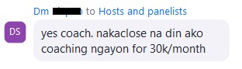
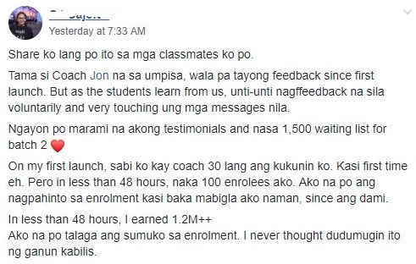

How to Add It To Your System
Step 1: Deliver a great experience with your first product
Step 2: Mention that you offer premium help
Step 3: Use a simple line like:
“If you want me to personally help you apply this faster and avoid beginner mistakes, message me the word ‘upgrade.’”
No pressure. No hype. Just real value for serious people.
This Is Where Your Income Jumps
Look at the math:
- Sell 10 eBooks at ₱500 = ₱5,000
- Sell 1 higher-ticket offer at ₱25,000 = ₱25,000
- Sell both? That’s ₱30,000 a day.
Hindi mo kailangan ng 1,000 sales. You just need a few serious buyers who want more help.

You’re Not Being Greedy—You’re Being Strategic
You’re not forcing anyone.
You’re simply saying:
“If you want faster results, I can help—at a premium level.”
That’s not pressure. That’s leadership.
Next up…
Let’s talk about stepping back and building freedom—so your system runs even when you don’t feel like working.

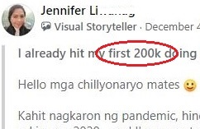

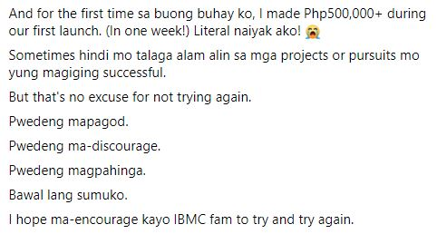

Chapter Ten
Systematize and Step Back
(And Become a “Chillyonaryo.”)
Let me tell you something most “online earners” never admit:
They’re not free. They’re trapped.
Trapped in daily posting. Trapped in replying to DMs.
Just like traditional business owners na akala mo may negosyo, pero ang totoo, sila pa rin ang ‘taga-bukas ng tindahan, taga-sagot ng inquiry, taga-habol ng delivery, at minsan, taga-kolekta pa.’
Trapped in the same hustle loop—just in digital form.
Sure, they’re making money.
But miss one post, one week, one campaign?
Boom—zero.
Kung titingnan mo, parang business…
Pero sa totoo lang, sila pa rin ang makina.
And that’s NOT the goal here.

This Chapter Is About Becoming A Chillyonaryo.
We didn’t build this ₱10K/day system para lang palitan yung 8–5 ng bagong kulungan.
You built this to escape that.
And now, it’s time to turn your system into a machine—something that still runs even if:
- You're sick
- You're offline
- Or you simply want to rest
Because what’s the point of having income kung hindi ka rin makalayo dito kahit dalawang araw?
Here’s How You Step Back (Without Losing Income)
You don’t need to disappear.
But you do need to replace your presence with a process.
Let me show you how:

1. Recycle Your Content
The post that made ₱10K? Repost it next month.
The story that pulled buyers in? Re-share with a new angle.
Stop reinventing the wheel. Start rotating your hits.

2. Automate Your Follow-Up
Use email sequences. Use chat triggers. Use tools that remind people, even if ikaw mismo tulog.
Set it once. Let it work forever.
3. Systematize Your Delivery
Your product delivery?
Automate it through:
- Google Drive access
- Gumroad / Payhip links
- Auto-reply messages
No more manual sending. No more “Hi po, na-send ko na po!”

4. Delegate Low-Value Tasks
Pag may kita ka na?
Hire a VA.
Let someone else handle:
- Comment replies
- GCash confirmations
- Buyer support
You focus on strategy.
Let someone else do the repeatables.

5. Batch Your Content
Instead of posting every day, do it once a week.
One sitting. Five posts. Then schedule them. Then walk away.
Content still goes out—kahit nagbabakasyon ka.

This Is The Final Shift…
You’re no longer just selling.
You’re building a machine that sells, delivers, and follows up without you.
And that, my friend? That’s a business.
Not just a side hustle.
Not just a daily grind.
It’s a system.
A system that pays you daily.
In your pambahay.
Even while resting, healing, or having fun.


One Last Thing…

Anong Itsura ng Buhay ng Isang Chillyonaryo?
Let’s go back to your why.
You didn’t start this just to make ₱500 from a Google Doc.
Or to get likes on Facebook.
You started this kasi pagod ka na.
Pagod sa sweldo na bitin.
Pagod sa trapik, sa toxic na trabaho, sa paulit-ulit na cycle.
And deep down…
You want peace.
You want time.
You want choice.
That’s what it means to be a Chillyonaryo.
Hindi lang may pera—
Pero may ginhawa.

Imagine this...
You wake up when you want.
Hindi dahil may pasok, kundi dahil well-rested ka.
You check your phone…
May nagpadala ng payment habang natutulog ka.
Walang pakiusap. Walang “follow-up po.”
You get up, brew your 3-in-1 or kapeng barako...
No rush.
No alarm.
Walang trapik. Walang manager. Walang “ASAP.”
Maybe you bring your kids to school habang chill lang ang umaga.
Maybe you and your spouse go for a quick brunch on a Tuesday—kasi libre ang oras mo.
Maybe you go for a haircut sa oras na walang pila.
Maybe you start jogging, journaling, or just sit quietly kasi wala ka ng worry sa mga bills.
You finally have space to breathe. Di ka sakal.
Space to think.
Space to live.
And your business?
- It’s running in the background.
- Products are still selling.
- Systems are still working.
- Automation is doing its job.
Hindi ka nakatali sa laptop.
Hindi ka takot magbakasyon.
Hindi mo kailangan ng 10 clients to “make ends meet.”
Because now—you earn with leverage, not labor.
This is the Chillyonaryo life.
- May kita kahit naka-tsinelas
- May peace kahit may bills
- May sistema, hindi stress
- May time para sa pamilya, sarili, at buhay na totoo
Hindi ka superstar.
Hindi ka influencer.
Pero may sarili kang sistema na tahimik pero tuloy-tuloy ang income.
That’s not a dream.
That’s the reward for building it right.
And now that you’ve seen the blueprint…
the only question is: Will you build it?
Let’s go to our final chapter.

Final Chapter
What Happens When You Finally Decide to Build It?
Now you’ve seen it.
The entire ₱2,000 - ₱10,000/day system.
No fluff. No magic app. Just real steps na kahit sino—kahit ikaw—pwedeng simulan.
You now know:
- How to find a pain that pays
- How to create a simple digital product
- How to build a 1-page sales machine
- How to use social media without becoming a content creator
- How to follow up like a pro
- How to introduce bigger offers
- And how to systematize it para hindi ka na nega tuwing Monday
You’re no longer in the dark.
And now, may dalawang direction ka lang pwedeng tahakin:

❌ Option 1: Close This PDF, Balik Sa Dating Gawi
Scroll ulit.
Download ulit.
Overthink ulit.
Next month, you’ll still be in the same spot—probably saying:
“Sana sinimulan ko na ‘to noon pa.”

✅ Option 2: Build the Chillyonaryo System—One Step at a Time
You don’t need to be perfect.
You just need to start.
This is not a race.
This is a lifestyle.
And every day you delay…is a day na sayang ang potential mo.
Sayang ang peace of mind.
Sayang ang Chillyonaryo life waiting for you on the other side.
“But Jon... what if I try ulit, then fail na naman?”
That’s a fair question.
And here’s the honest answer:
You might fail. Not because the system doesn’t work…
But because you’ll need time to get it right.
Ang sikreto?
Those who win are not the fastest. They’re the ones who stayed in the game the longest.
The first time I launched my product, ang kaba ko grabe.
I got one sale. Akala ko malas.
Pero that one sale? Was proof that it works.
Hindi ako kumita ng milyones from that one product. But that proof gave me the courage to keep going. Makes sense?
Now, thousands of sales later… I’m grateful I didn’t quit too soon.
So if you’re scared to try again—good.
That means you care.
But don’t let fear decide your future.
Let progress decide it.

What’s next from here?
Simple lang.
If you need my team’s help with implementing this ₱30,000/day Chillyonaryo System…
Then, click this link and book a FREE 60-minute consultation with our team.
Let’s talk.
Let’s build your version of this system.
Let’s get you earning from what you know, what you’ve lived through, what you’ve figured out.
Because this system? It’s real.
Not easy. Not instant.
But simple. And worth it.
So the next time someone asks you,
“Anong ginagawa mo ngayon?”
You can smile and say:
“Nasa bahay lang. Nakapambahay. Pero tuloy pa rin ang kita.”
And just like that—
You’re no longer stuck.
You’re no longer guessing.
You’re no longer dreaming.
You’re building.
Because now?
You’re becoming a Chillyonaryo.

Let’s End With Some Real Talk.
I don’t want to insult your intelligence.
This system is simple—but it’s not easy.
You’ll need to learn new skills.
You’ll need to show up even when you're tired.
You’ll need to make uncomfortable decisions.
Pero eto ang tanong:
Isn’t your life already hard?
The stress. The work. The bills. The burnout.
So if mahirap din lang naman…
Why not build something that gives you freedom in return?
Kasi yung ginagawa mo ngayon? Hard din.
Pero walang leverage. Walang peace. Walang ginhawa.
You see, this isn’t just about making money online.
This is about reclaiming your time, your choices, your life.
Hindi ito para sa lahat.
Pero maybe—just maybe—ito na ang simula ng bago mong buhay.
Kaya kung ready ka na…
Let’s build it your Chillyonaryo System.
Chat with one of our advisors for a free consultation. And we’ll see if we can help you.
To your freedom,
Jon Oraña
Real People. Real Transformation.

